

**Dozentur   
Produktion und Logistik**Priv.-Doz. Dr. Rainer Kleber

Project Report

Lecture Business Forecasting

Mine Case 2

Showmik Das

ID : 220613

Ghislain Karrel Djeukou Nouendoui

ID :223882

Thi Tram Anh Trinh

ID : 221563

Date : 7/2/2019

# 

Table of Contents

List of the Tables ii

List of Figures: ii

1. Introduction 1

2.1 Initial data analysis: 1

2.3 ETS model selection : 1

2.4 ARIMA model selection: 2

2.5 Model Diagnostics: 3

3. Conclusion : 3

List of the Tables:

Table 1: Proposed candidate model and their respective information criteria………………2

Table 2: Performance measurement of the forecast models in terms of RMSE…………….3

# List of Figures:

Figure 1: Decomposing the initial data to understand the components of the time series.....1

Figure 2: Graphical representation of forecast with ETS(A,N,A) model………………...…2

Figure 3: Graphical representation of forecast with ARIMA(1,0,1)(1,1,1) model………….3

Figure 4: Residuals of the proposed ARIMA(1,0,1)(1,1,1) model…………………………….3

# 1. Introduction

We are asked to develop an appropriate forecasting method for the given data set consisting average temperature, total rain, total sunshine observed in Magdeburg from Jan/1989 to May/2019 named as Magdeburgweather.xlsx. Our objectives are:

* Developing appropriate forecast method for the given series using state space model and ARIMA/SARIMA model.
* Using an appropriated benchmark method and compare the performance of the methods.

## 2.1 Initial data analysis:

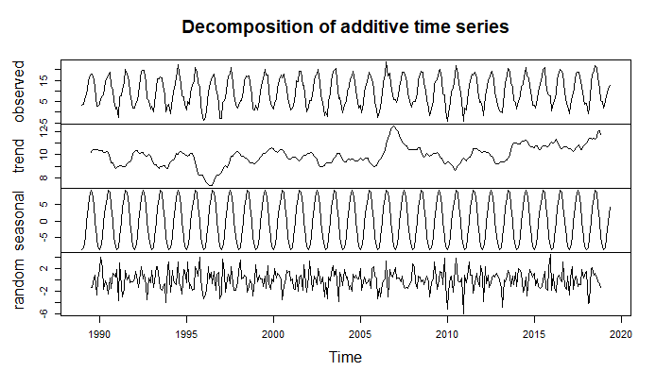Figure 1: Decomposing the initial data to understand the components of the time series

The figure represents the trend, seasonality and the random error of the given data. It is not that much clear from the data that it has a considerable trend of not but it clearly shows the additive seasonality of the data which is quite obvious as we are dealing with the average temperatures.

**2.2** Selecting an appropriate forecast method:

After the initial data analysis, our task is to select the appropriate forecast method for the given data set. As per the requirement, we will use ETS (state space model) and SARIMA (p,d,q)(P,D,Q) model to and compare the forecast with a benchmark method.

## 2.3 ETS model selection:

We perform the ets model selection by passing our training data in the ets() function and

find that the data consists of additive error, no trend and additive seasonality with certain parameters.

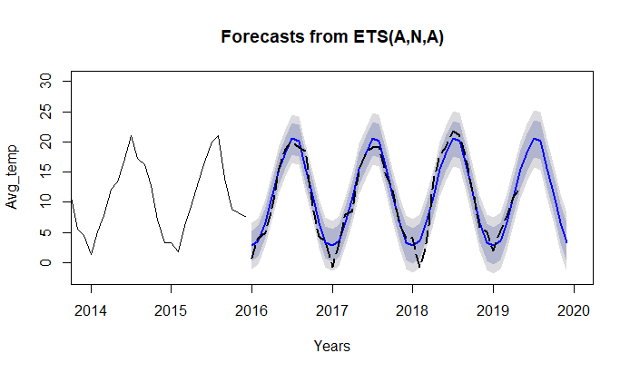Figure 2: Graphical representation of forecast with ETS(A,N,A)

The black dotted line shows the observed data in our test set and the blue line is the forecasted data from our model. It is quite visible that the model almost captured the pattern in the test data for the summer season but somehow the deviation is much higher from the observed data for winter.

## 2.4 ARIMA model selection:

Before proceeding with ARIMA model selection, we need to check whether the data is stationary or not. We can check it using the ndiffs()/nsdiffs() functions . We found that our data is stationary for the normal term but the existing seasonality is not stationary. After that, we explore the ACF and PACF graphs and generate the following candidate models along with information criteria.

|  |  |  |
| --- | --- | --- |
| Candidate models | AIC | BIC |
| ARIMA(1,0,1)(1,1,0) | 1434.24 | 1449.23 |
| ARIMA(1,0,1)(1,1,1) | 1331.72 | **1350.44** |
| ARIMA(1,0,1)(2,1,1) | 1331.56 | 1354.02 |

Table 1: Proposed candidate model and their respective information criteria .

We decided to use BIC as the measure for information criteria and we chose ARIMA(1,0,1)(1,1,1) as it has the lowest BIC among all the three candidate models .

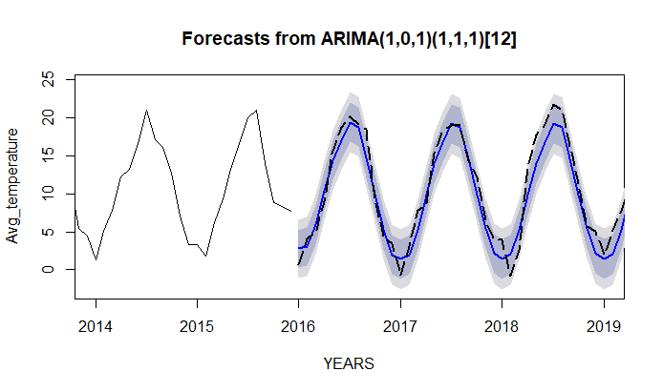Figure 3: Graphical representation of forecast with ARIMA(1,0,1)(1,1,1)

## 2.5 Model Diagnostics:

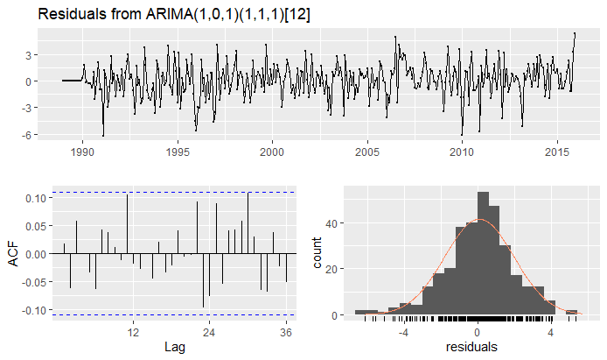

Figure 4: Residuals of the proposed ARIMA(1,0,1)(1,1,1) model

The residual shows a somewhat normal distribution as the histogram is kind of bell-shaped. There exists an outlier that needs to be adjusted. There is no evidence of residual autocorrelation. There is no significant spike and no zig-zag pattern so no need for including further MA term. The residual pot forms a funnel shape so no transformation is needed to stabilize the variance.

|  |  |
| --- | --- |
| Forecast Model | RMSE |
| Seasonal Naïve | 2.9877 |
| ETS(A,N,A) | 1.8339 |
| ARIMA(1,0,1)(1,1,1) | 1.9899 |

Table 2: Performance measurement of the forecast models in terms of RMSE

# 3. Conclusion:

We found that the ETS (A, N, A) model worked best for the given data set. We cannot specifically conclude about global warming, as we need more relative data of the temperatures of other cities but surely there is local warming in Magdeburg as the temperature in summer has a tendency to rise higher in the coming future days.